* All characters stay the same
* Cone breath as a powerup
* Main weapon is a projectile with a limited range
* Viewpoint - top down from a 45 degree angle
* Powerups change attack types - bomb, cone, freeze
  + Bomb, freeze - single use
  + Cone - few seconds
* Shove? - no, lets revisit when we build core gameplay
* All critters the same
* Jump not fly
* No dodge
* Map a picture of a controller
* 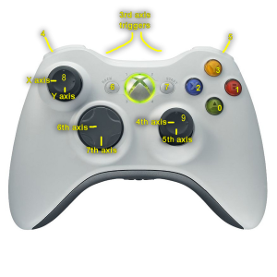
* Health bars above players - 3 hits
  + When players lose 3 ticks, they get stunned for X seconds
  + Revive - invulnerable for X seconds
* Maps
  + Bordered, walled
  + symmetric
* Critters
  + Spawn from the edge/randomly from set points in map
  + Ideal number on screen? 15-20
  + 1 type to start with
* Points/Humourous Title after game (may or may not add to main points)
  + Points from stunning a player
  + Points from critters
* Traps
  + New feature - just suggested